Ex01:

A.

Figure 1. The AOA network diagram.

B.

Path 1: A-E-J Length = 10+8+12 = 30 days

Path 2: A-D-F-G-J Length = 10+4+6+4+12 = 36 days

Path 3: A-D-F-H-K-L Length = 10+4+6+8+8+10 = 46 days

Path 4: A-D-F-G-I-K-L Length = 10+4+6+4+6+8+10 = 48 days

Path 5: B-F-G-J Length = 12+6+4+12 = 34 days

Path 6: B-F-G-I-K-L Length = 12+6+4+6+8+10 = 36 days

Path 7: B-F-G-H-K-L Length = 12+6+4+8+8+10 = 48 days

Path 8: C-G-J Length = 8+4+12= 24 days

Path 9: C-G-I-K-L Length = 8+4+6+8+10 = 36 days

Path 10: C-H-K-L Length = 8+8+8+10 = 34 days

Path 11: A-E-I-K-L Length = 10+8+6+8+10 = 42 days

C.

The critical path for this project is Path 4. Since it is the longest path in the network diagram and it covers most of the activities in the project.

D.

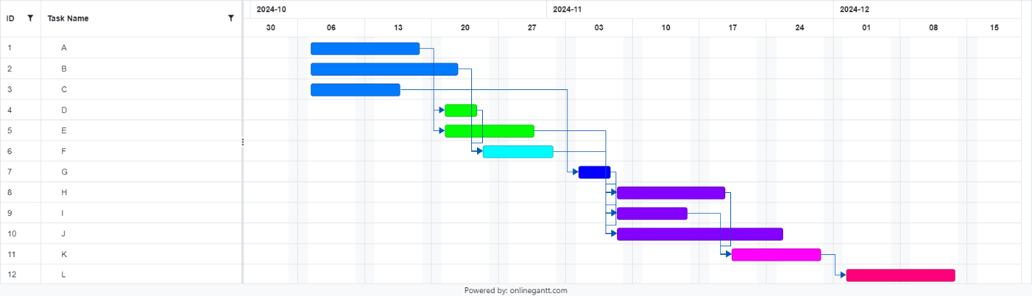

Figure 2. The gantt chart for the project.